**Project of Insertion Sort**

1. **Stages of Sorting according to Insertion Sort**

[22,27,16,2,18,6]

Step 1: [2,27,16,22,18,6]

Step 2: [2,6,16,22,18,27]

Step 3: [2,6,16,18,22,27]

**2) Big-0 =** O(n^ 2) → Quadratic

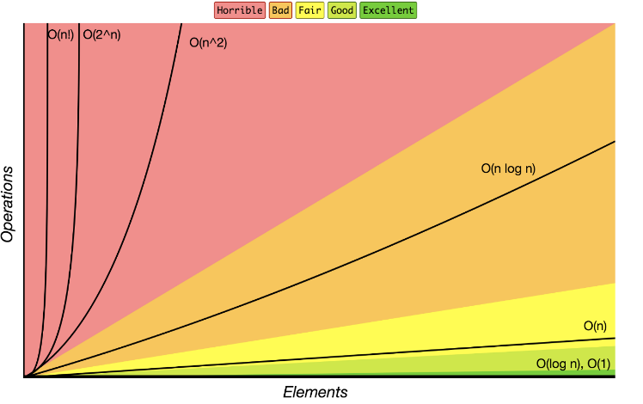

**3)**\*\*Best Case: if all the values are given in order, this is BEST CASE.

**Average Case: If the number we are looking for is in the middle of list, this is AVARAGE CASE.

**Worst Case: If the number we are looking for is in the end of list, this is WORST CASE.

**4)** If we are looking for ‘’18’’, this situation will be average case.

**5) Stages of Sorting according to Insertion Sort**

[7,3,5,8,2,9,4,15,6]

Step 1: [2,3,5,8,7,9,4,15,6]

Step 2: [2,3,4,8,7,9,5,15,6]

Step 3: [2,3,4,5,7,9,8,15,6]

Step 4: [2,3,4,5,6,9,8,15,7]